**behavioral state machine**

The behavioral state machine shows the change about the book when it is borrowed.

行為狀態機顯示書本借閱時的變化情形

First, the book will confirm inventory, and if not, the states is ended.

首先書本會先確認有沒有庫存，如果沒有就結束該狀態

If there are books inventory, the book will be updated.

如果有剩餘得庫存書籍，會更新數量

Then the user can take the book away to the counter for borrowing,

那用戶可以拿這本書至櫃台進行借閱

but it may also possible take away the book no borrow,so it shoud be update.

但是也有可能發生拿了書卻沒有借閱，所以要持續的更新系統

After the user take the book the counter, the ID will be verified first.

那用戶拿到櫃台後會先驗證ID

After the verification is completed and comfirm the borrower, the states is ended.

驗證完成後及代表借閱完成，並結束該狀態。

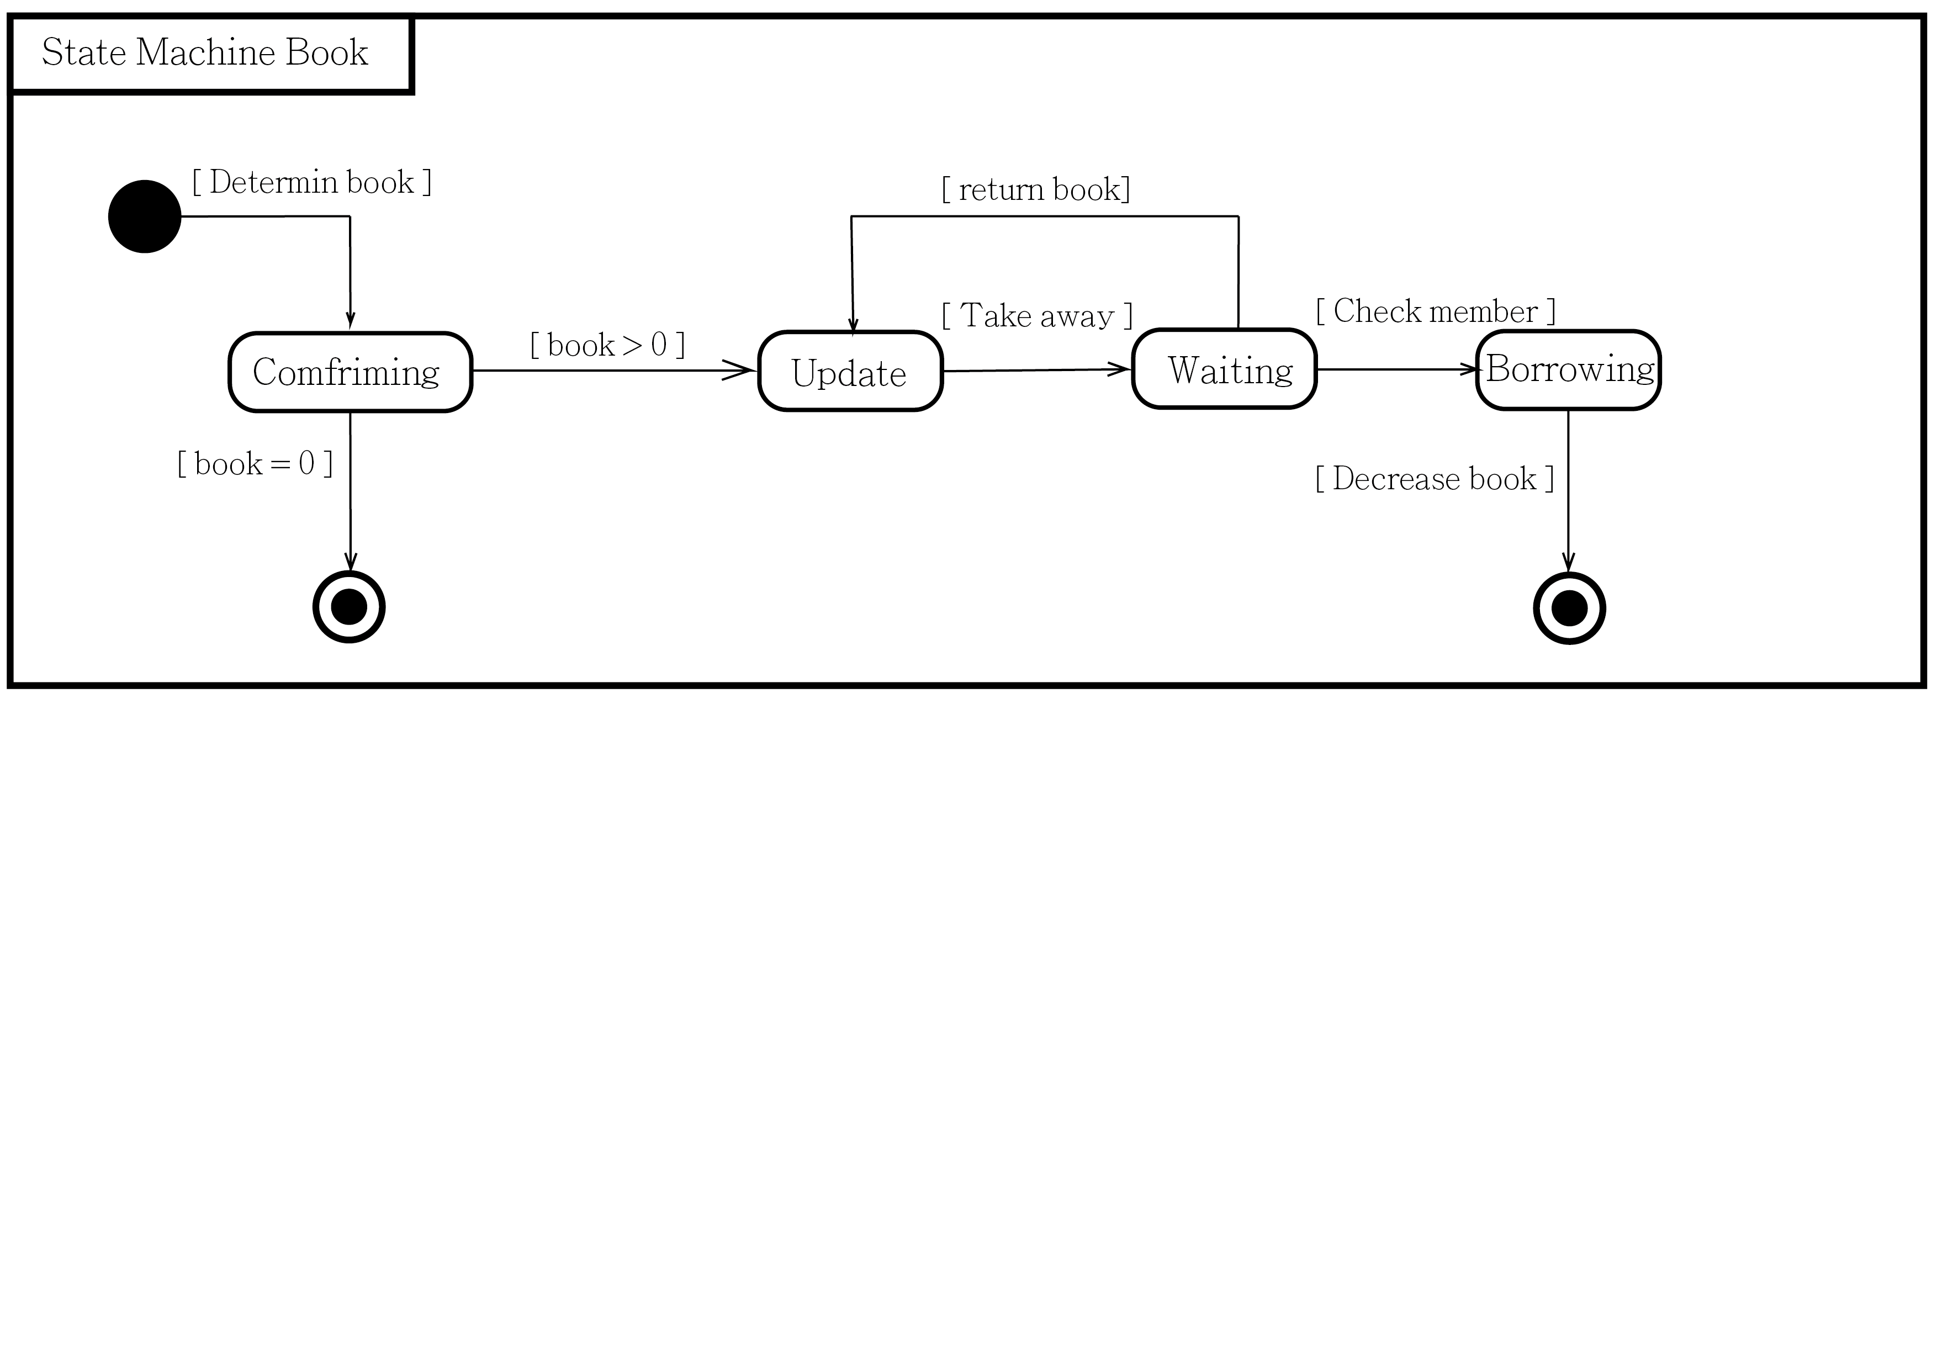

文字分離版

The behavioral state machine shows the change about the book when it is borrowed.

First, the book will confirm inventory, and if not, the states is ended.

If there are books inventory, the book will be updated.

Then the user can take the book away to the counter for borrowing,

but it may also possible take away the book no borrow,so it shoud be update.

After the user take the book the counter, the ID will be verified first.

After the verification is completed and comfirm the borrower, the states is ended.

行為狀態機顯示書本借閱時的變化情形

首先書本會先確認有沒有庫存，如果沒有就結束該狀態

如果有剩餘得庫存書籍，會更新數量

那用戶可以拿這本書至櫃台進行借閱

但是也有可能發生拿了書卻沒有借閱，所以要持續的更新系統

那用戶拿到櫃台後會先驗證ID

驗證完成後及代表借閱完成，並結束該狀態。